A Unified Disturbance–Resilience Framework

Hung-wei Lin

Big idea
- The way to unify pulse and press is to treat pulse as an ended press. Before it ends, it is a press; once it ends, it is a pulse. Time is zoomable, so the essence between pulse and press is simply: does the disturbance end?
- There are only five basic metrics (resilience components) in my opinion: (a) Disturbed Equation, (b) Adaptation Equation, (c) Recovery Equation, (d) Recovery Degree, (e) Tipping Point.
1) Press vs. Pulse — same movie, different zoom, the only different is whether it's ended
How pulse become press when I zoom out: Long-term hunting pressure, frequent small fires, repeated flood pulses → at coarse time scales these merges into a press.
Example (population view): counting abundance daily shows spiky pulses; averaging vital rates yearly looks like a smooth press.

How a press becomes a pulse when it ends 'quickly': Global warming for "a year,” a one-time grazing → if it ended and I zoomed out, I could call it a pulse.
Example (palaeoecology view): a brief cooling event in sediments is a pulse, even if it's more than 100~1000 years.
Ramps: A ramp is just many pulses whose intensity increases; zoomed out, it reads as a press with a rising level (e.g., global keep warming, steadily increasing nutrient loading).
Conclusion: because time can be zoomed, the most complete way to write a disturbance–resilience framework is to show an “ended press”. Before it ends, it’s a press (traditional); after it ends, it’s a pulse (traditional).

2) My ended-press story (constant-k version first)
Set-up. A press P acts from t₀ to t₁ with fixed intensity ΔK.
The target variable starts at N₀. While the press is still on, the system reaches and then maintains N₁ at t₁. I can read off:
- Two differences and one trajectory:
  - ΔN = N₁ − N₀ (how far the target has moved by the time it stabilises under the press).
  - Δt = t₁ − t₀ (how long it took to settle under the press).
  - A curve N(t) from t₀ to t₁ (how the N₀ approaches N₁).
All three depend on the system’s internal makeup.
- Disturbed Equation (DE) — amplitude while the press is on
I relate press intensity to the raw displacement the press would cause if nothing pushed back:
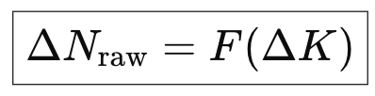
For a single fixed press, I use the local linearisation:
ΔNraw​ ≈ S⋅ΔK
- S is the sensitivity coefficient.
  - S>0 ⇒ compensation (the target’s initial response goes with the press).
  - S<0 ⇒ resistance (the initial response goes against it).
Intuition by examples (quick):
shade on plants (more shade → bigger raw drop in photosynthesis); extra fishing mortality (higher ΔK → larger raw drop in spawning biomass).
In real life ΔK ↔ ΔN often isn’t perfectly linear, so DE is the function FFF (dose/press–response). The linear form is just its local slope S at the ΔK I’m analysing.
- Adaptation Equation (AE) — time course while the press is on
First, I show the constant-A version (single time scale). Then I discuss how A really comes from b and r.
2a) AE with constant A (one time scale; simplest to see)
I define the “time to settle under the press” as
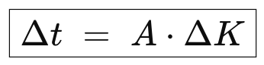
A is the adaption coefficient. Bigger A means slower settling (more time per unit press). The reason no one noticed the adaptation in the pulse scenario was that Δt was too short.
What this looks like in practice:
- Mild drought (ΔK small) and a system with small A → settles fast (large k).
- Severe ΔK or large A → settles slowly (small k).
Either way, while the press is ongoing there is no recovery equation; but what I see is adaption under the press.

2b) AE with time-varying A (what A really depends on)
After showing the simple curve, I reveal that A isn’t fundamental; it emerges from two lower-level features acting in parallel:
- Buffering capacity b_{j}​: how much a lower-level (at level j) unit can ultimately contribute to the adaptation (push back).
- Reorganisation rate r_{j}​: how quickly unused buffering capacity is turned into effective adaptation (think “tap opening” on a tank of size b_{j})
Together, b and r will create mobilisation. Cumulative mobilisation while the press persists:
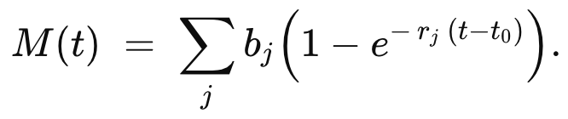
Net deviation (direction set by S, magnitude shrinks as mobilisation grows):
Long-run under a sustained press (with B_{tot}​=∑b_{j}​):
These give me a time-varying “effective A”. A handy approximation that matches the early-time limit is:
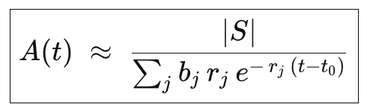
Early on: many small-and-fast units dominate (denominator big) → A(t) small → fast approach.
Later: quick buffers saturate, slower layers matter → denominator shrinks → A(t) grows → approach slows.
If smaller levels are faster (larger r_{j}), but hold less buffering capacity (b_{j}), I naturally get fast-then-slow curves.
Concrete pictures (A via b & r):
- By-catch pressure: avoidance behaviour (small b, high r) → fast; life-history shifts (large b, low r) → slow. evolution (super large b, super low r).
- Forest under global warming: physiological acclimation (small b, high r) → fast; community reassembly (moderate b, moderate r) → intermediate; evolutionary adaptation (large b, low r) → slow.

---------------------------------------------------------------
Up to t₁ (from t₀) I’m describing the press-phase dynamics. The period t₁→t₂ is simply “press maintained at the new level”. From t₂ (when the press ends) to t₃ is the recovery-phase (that’s where Recovery Equation (RE), Recovery degree (RD), Tipping Point (TP) live; I’m not covering them today, that’s see your opinion on t₀ to t₁ first). However, I could say unlike adaptation equation, recovery equation is so easy to understand: The well-known engineering resilience is a linear or local version of recovery equation. The others two components are also not uncommon.
The hard thing for me to describing the recovery phase is that I don’t yet know how to carry over the multi-level (jjj) idea I proposed in the AE into the RE so far. Nor am I sure how to disentangle RD from alternative stable states (ASS). My hunch is that if I can solve the first problem, the second might follow: and RD and TP could even turn out not to be basic metrics at all (i.e., they could be computed from other basics). That may be too optimistic, so I don’t want to overpromise. Still, I don’t think it’s hopeless. Imagine that RE is also a multi-level process, and that the rj values among levels are exponentially different, so the rj values between two specific different levels will be widely separated (at least on our human observation timescales). Then not only could ASS be naturally accommodated, but this would also align with a common empirical pattern: recovery speed slows as the system approaches a TP.
That said, my multi-level assumption is fairly abstract, and I suspect it looks quite different across ecological levels, in other words, it’s at least not as simple as a fractal. So, I can’t guarantee it will unify resilience across scales. But it may still be worth serious exploration.

